Lincoln House School

Relationships and Sex Education (RSE)

Policy

|  |  |  |  |
| --- | --- | --- | --- |
| Signed by:  Emma Crowshaw Headteacher                   Date: September 2024 | | | |
| C. Raducanescu | Education Director | Date: | September 2024 | |
| Natalie Moore | Regional Head Teacher/SENDCO | Date: | September 2024 | |

**Review Date: September 2025**

**Contents**

1. Introduction and aims 3,4
2. Statutory requirements 4
3. Policy development 5
4. Definition 5
5. Curriculum 5,6
6. Delivery of RSE 6,7
7. Roles and responsibilities 7

8 Pupils...................................................................................... 8

1. Parents’ right to withdraw 8,9
2. Training 9
3. Monitoring arrangements 9

Appendix 1: Curriculum Map 10

Appendix 2: By the end of secondary school, pupils should know 11,12,13

Appendix 3: Parent/ Careers form: Withdrawal from sex education within RSE 14

Appendix 4: DfE RSE Statutory Guidance Suggested Resources 15

# Introduction and aims

The purpose of this policy is to ensure that our Relationships and Sex Education (RSE) and Health Education supports our school ethos and fulfils our school aims, which are defined as:

* + to develop the whole individual through high quality learning experiences and opportunities for Character Development.
  + to promote high levels of personal esteem, resilience, confidence and courtesy.
  + to create an environment in which we each respect and value each other's rights, needs and abilities.
  + to prepare pupils for the future, promoting a global perspective

This policy applies to all pupils within our school.

This policy forms part of our curriculum.

We see the curriculum as, ‘The total learning experience for our pupils, which includes not only the taught lessons but also the routines, behaviour, events, activities, and other opportunities that our pupils experience on a daily, weekly and yearly basis in order to ensure that all of them make the best progress possible and attain high standards’.

A well-structured and coherent curriculum is a fundamental element of the tripartite education that underpins all successful schools and includes Teaching, Learning and Assessment (see model below) and is underpinned by Wellbeing for Life Model.

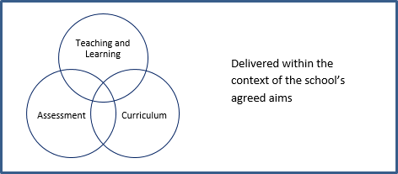

The aims of RSE at our school are to:

Provide a framework in which sensitive discussions can take place.

To support the School Behaviour Policy and ethos/values.

Ensure that every pupil is provided with RSE, except for those excused.

Prepare pupils for puberty and give them an understanding of sexual development and the importance of health and hygiene.

Help pupils develop feelings of self-respect, confidence and empathy.

Create a positive culture around sexuality and relationships.

Teach pupils the correct vocabulary to describe themselves and their bodies.

Help pupils understand that healthy relationships are an important part of wellbeing.

Ensure that key issues related to sexualities are not taught in isolation but in part of a broader context.

To ensure young people stay safe and healthy and manage their academic, personal and social life positively.

# Statutory requirements

* + Our policy follows the statutory guidance given by the Government (DfE) and meets the requirements of the Independent School Standards.
  + Aspects of RSE are infused within the day-to-day operation of our school; incorporated.
    - through the curriculum, both in content included in subject schemes of work and through other planned learning opportunities in the school. They are captured in our written aims and expressed in the ethos and behaviour of everyone.
  + In our School, we must ensure that every registered pupil who is provided with secondary education at the school is provided with relationships and sex education, except in so far as the pupil is excused as mentioned in sub-paragraph 9, in accordance with sections 34 & 35 of Children and Social Work Act 2017 and the Independent School Standards, and with regard to guidance outlined in Section 403 of the Education Act 1996, as issued by the Secretary of State.

As an independent school we must provide Relationships Education to all our pupils as stated in the ‘Relationships and Sex Education and Health Education (England) Regulations 2019’. Updates: 1.09.2021

At our school, we teach RSE as set out in this policy.

# Policy development

The RSE policy has been developed in consultation with staff. The consultation and policy development process involved the following steps:

* + Review – The Headteacher reviewed all relevant information, including but not limited to, relevant national and local guidance.
  + The policy is in accordance with statutory guidance and aligned with the Independent School Regulations.
  + Staff consultation – school staff were given the opportunity to review the policy and make recommendations.
  + Ratification – once amendments were made, the policy was shared with the Education Director and ratified.
  + Policy review – this policy will be reviewed in August 2026.

# Definition

* 1. RSE is about the emotional, social and cultural development of pupils, and involves learning about relationships, sexual health, sexuality, healthy lifestyles, diversity and personal identity.
  2. RSE involves a combination of sharing information and exploring issues and values.
  3. RSE importantly makes the distinction between the physical action of sexual activity and the emotional relationships that comes with it.
  4. RSE is not about the promotion of sexual activity, sexual orientation, or a specific sexual identity.

# Curriculum

* 1. Our curriculum is set out in Appendix 1, but we may need to adapt this as and when necessary.
  2. We have developed the curriculum in consultation with the staff, taking into account the age, needs and feelings of pupils via MDT’s, PEP’s, EHCP, questionaries. If pupils ask questions outside the scope of this policy, teachers will respond in an appropriate manner, so they are fully informed and do not seek answers online.
  3. The RSE and PSHE curriculum compliments the whole school approach to pupil well-being and links to the school’s other policies such as Behaviour, Anti Bullying and Safeguarding Policies.

# Delivery of RSE

* 1. RSE is taught within the PSHE curriculum. The PSHE course is delivered to all pupils through discrete weekly PSHE lessons taught by teachers (see **Appendix 1**). Elements of the program may be supported through the bringing in of additional expertise, such as outside speakers, trained health professionals, or the use of teachers with a particular interest or knowledge in a specific area.
  2. The curriculum content is delivered in a non-judgmental and factual way which allows pupils to ask questions, either as part of a group or through anonymousness such as question boxes.
  3. Relationships Education focuses on teaching the fundamental building blocks and characteristics of positive relationships, helping them to develop healthy, nurturing relationships of all kinds, including:
     + Families and people who care for me.
     + Respectful relationships, including caring friendships.
     + Online and media.
     + Being safe
     + Intimate and sexual relationships, including sexual health. (Age appropriate or depending on the context of students)

In addition to these discrete sessions, PSHE is also embedded within the curriculum (E.g., social issues through the teaching of English Literature; Health through Biology and PE; Citizenship through History & RE). There are also centrally organised sessions which supplement the delivery in-house.

Aspects of RSE are also taught within the Science curriculum by education staff.

* describe the role of hormones in human reproduction including the control of the menstrual cycle.
* oestrogen, progesterone, FSH and testosterone
* explain the interactions of FSH, LH, oestrogen and progesterone in the control of the menstrual cycle.
* explain the use of hormones in contraception and evaluate hormonal and non-hormonal methods of contraception.
* relative effectiveness of the different forms of contraception
* discussion into the various methods of contraception and their effective/ethical use
* explain the use of hormones in modern reproductive technologies to treat infertility.

Other aspects such as families, different types of relationships and marriage, divorce and IVF treatment are included in RSE.

* + The areas of learning for family are taught within the context of family life, taking care to ensure that there is no stigmatisation of children based on their home circumstances (families can include single parent families, LGBTQ+ parents, families headed by grandparents, adoptive parents, foster parents/carers amongst other structures), along with reflecting sensitively that some children may have a different structure of support around them (for example: looked after children or young carers).
  + Additional aspects can be covered in assemblies and form/tutor time activities. The religious background of all pupils will be considered, and activities planned accordingly to ensure all content is handled sensitively and appropriately.
  + For more information about our RSE curriculum, see Appendices 1 and 2.

# Roles and responsibilities

# 

**The Education Director and Regional Head Teacher/SENDCO**

The Education Director and Regional Head Teacher/SENDCO will approve the RSE policy and hold the Headteacher to account for its implementation.

The Education Director and Regional Head Teacher/SENDCO will ensure that:

* + all pupils make progress in achieving the expected educational outcomes.
  + The subjects are well led, effectively managed and well planned.
  + The quality of provision is subject to regular and effective self-evaluation.
  + teaching is delivered in ways that are accessible to all pupils with SEND.
  + clear information is provided for parents/ careers on the subject content and

the right to request that their child is withdrawn; and,

* + the subjects are resourced, staffed and timetabled in a way that ensures that

the school can fulfil its legal obligations.

# The Headteacher

The Headteacher is responsible for ensuring that RSE is taught consistently across the school, and for managing requests to withdraw pupils from [non-statutory/non-science] components of RSE (see section 8).

# Leadership and Overview

The staff who have the main responsibility for the overview and yearly evaluation of this policy are the Headteacher, Education Director and Regional Head Teacher/SENDCO. However, all staff are responsible for ensuring this policy is implemented and acted on.

When evaluating the use and impact of this policy, the Headteacher will evaluate the extent to which there is evidence of a curriculum which:

* + Fulfils the aims of the school.
  + Embeds aspiration, attributes and the expectation to achieve high standards and high rates of progress; and
  + Provides engagement and excitement for learning.

# Staff

Staff are responsible for:

* Delivering RSE in a sensitive way.
* Modelling positive attitudes to RSE.
* Monitoring progress.
* Responding to the needs of individual pupils; and
* Responding appropriately to pupils whose parents/careers wish them to be

withdrawn from the [non-statutory/non-science] components of RSE.

Staff do not have the right to opt out of teaching RSE. Staff who have concerns about teaching RSE are encouraged to discuss this with the Headteacher.

Staff who will be delivering RSE lessons are trained professionals.

# Pupils

Pupils are expected to engage fully in RSE and, when discussing issues related to RSE, treat others with respect and sensitivity.

# Pupils with Special Educational Needs and Disabilities

Our curriculum is inclusive and our RSE and Health Education is accessible for all pupils.

High quality teaching that is differentiated and personalised will be the starting point to ensure accessibility for all students.

The school is aware that some pupils are more vulnerable to exploitation, bullying and other issues due to the nature of their SEND. Relationships Education and RSE can also be particularly important subjects for some pupils; for example, those with Social, Emotional and Mental Health needs or learning disabilities. Such factors will be taken into consideration in designing and teaching these subjects.

# Parents’ right to withdraw

# If parents/careers require more information on RSE for secondary aged children, this is a useful information source of information for them:

[Understanding Relationships, Sex and Health Education - a guide for secondary school parents (publishing.service.gov.uk)](https://assets.publishing.service.gov.uk/government/uploads/system/uploads/attachment_data/file/907640/RSE_secondary_schools_guide_for_parents.pdf)

* 1. In our School, parents/careers have the right to withdraw their children from the non- statutory/non-science components of sex education within RSE up to and until 3 terms before the child turns 16. After this point, if the child wishes to receive sex education rather than being withdrawn, the school will arrange this. Students cannot be withdrawn from relationships education which includes topics such as friendships, settling in, different types of relationships and families.

Requests for withdrawal should be put in writing using the form found in Appendix 3 of this policy and addressed to the Headteacher.

A copy of withdrawal requests will be placed in the pupil’s educational record. The Headteacher will discuss the request with parents/ careers and take appropriate action.

Alternative work will be given to pupils who are withdrawn from sex education.

# Training

Staff are trained on the delivery of RSE as part of their professional development.

External visitors, such as school nurses or sexual health professionals, might be invited into school to provide support and training to staff teaching RSE and to review the teaching resources.

# Monitoring arrangements

The delivery of RSE is monitored by the Headteacher,Regional Head Teacher, Director of Education through:

* Line Management
* Learning walks
* Observations
* Pupil feedback
  1. The delivery of RSE is monitored by Cerasela Raducanescu, Natalie Moore through

work scrutiny, learning walks, Drop ins, Pupil Voice

11.2 Pupils ‘development in RSE is monitored by Headteacher and teachers/Instructors as part

of our internal assessment systems.

11.3 This policy will be reviewed by Headteacher and Education Director/

Regional Head Teacher/SENDCO annually.

Appendix 1 Relationships and Sex Education Curriculum Map

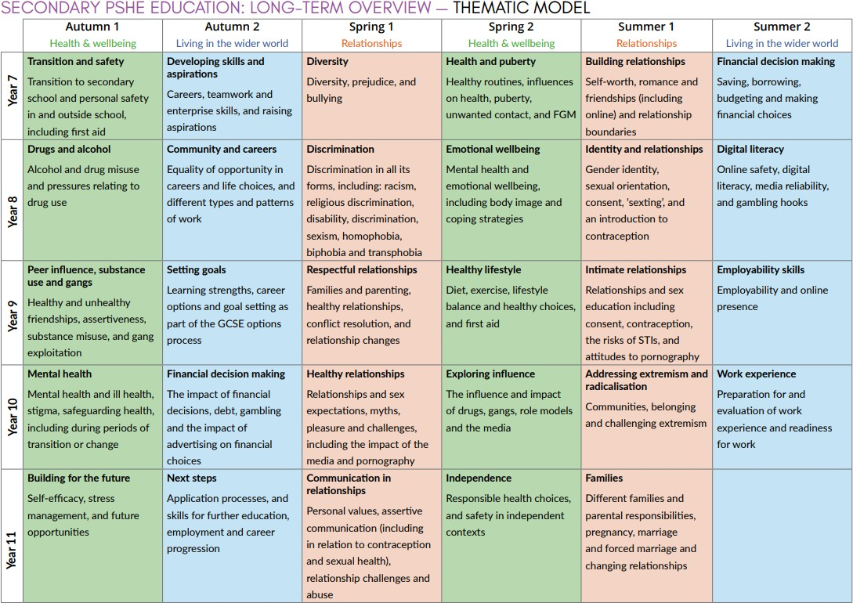

# Appendix 2: By the end of secondary school, pupils should know:

|  |  |
| --- | --- |
| TOPIC | PUPILS SHOULD KNOW |
| Families | * That there are different types of committed, stable relationships. * How these relationships might contribute to human happiness and their importance for bringing up children * What marriage is, including their legal status e.g., that marriage carries legal rights and protections not available to couples who are cohabiting or who have married, for example, in an unregistered religious ceremony * Why marriage is an important relationship choice for many couples and why it must be freely entered into * The characteristics and legal status of other types of long-term relationships * The roles and responsibilities of parents with respect to raising children, including the characteristics of successful parenting. * How to: determine whether other children, adults or sources of information are trustworthy: judge when a family, friend, intimate or other relationship is unsafe (and to recognise this in others’ relationships); and, how to seek help or advice, including reporting concerns about others, if needed |
| Respectful relationships, including friendships | * The characteristics of positive and healthy friendships (in all contexts, including online) including trust, respect, honesty, kindness, generosity, boundaries, privacy, consent and the management of conflict, reconciliation and ending relationships. This includes different (non-sexual) types of relationship. * Practical steps they can take in a range of different contexts to improve or support respectful relationships. * How stereotypes, in particular stereotypes based on sex, gender, race, religion, sexual orientation or disability, can cause damage (e.g., how they might normalise non-consensual behaviour or encourage prejudice) * That in school and in wider society they can expect to be treated with respect by others, and that in turn they should show due respect to others, including people in positions of authority and due tolerance of other people’s beliefs. * About different types of bullying (including cyberbullying), the impact of bullying, responsibilities of bystanders to report bullying and how and where to get help. * That some types of behaviour within relationships are criminal, including violent behaviour and coercive control. * What constitutes sexual harassment and sexual violence and why these are always unacceptable! * The legal rights and responsibilities regarding equality (particularly with reference to the protected characteristics as defined in the Equality Act 2010) and that everyone is unique and equal |

|  |  |
| --- | --- |
| TOPIC | PUPILS SHOULD KNOW |
| Online and media | * Their rights, responsibilities and opportunities online, including that the same expectations of behaviour apply in all contexts, including online. * About online risks, including that any material someone provides to another has the potential to be shared online and the difficulty of removing potentially compromising material placed online. * Not to provide material to others that they would not want shared further and not to share personal material which is sent to them. * What to do and where to get support to report material or manage issues online * The impact of viewing harmful content * That specifically sexually explicit material e.g., pornography presents a distorted picture of sexual behaviours, can damage the way people see themselves in relation to others and negatively affect how they behave towards sexual partners. * That sharing and viewing indecent images of children (including those created by children) is a criminal offence which carries severe penalties including jail. * How information and data is generated, collected, shared and used online |
| Being safe | * The concepts of, and laws relating to, sexual consent, sexual exploitation, abuse, grooming, coercion, harassment, rape, domestic abuse, forced marriage, honour-based violence and FGM, and how these can affect current and future relationships. * How people can actively communicate and recognise consent from others, including sexual consent, and how and when consent can be withdrawn (in all contexts, including online) |

|  |  |
| --- | --- |
| TOPIC | PUPILS SHOULD KNOW |
| Intimate and sexual relationships, including sexual health | * How to recognise the characteristics and positive aspects of healthy one-to-one intimate relationships, which include mutual respect, consent, loyalty, trust, shared interests and outlook, sex and friendship. * That all aspects of health can be affected by choices they make in sex and relationships, positively or negatively, e.g., physical, emotional, mental, sexual and reproductive health and wellbeing. * The facts about reproductive health, including fertility and the potential impact of lifestyle on fertility for men and women. * There are a range of strategies for identifying and managing sexual pressure, including understanding peer pressure, resisting pressure and not pressurising others. * That they have a choice to delay sex or to enjoy intimacy without sex * The facts about the full range of contraceptive choices, efficacy and options available * The facts around pregnancy, including miscarriage. * That there are choices in relation to pregnancy (with medically and legally accurate, impartial information on all options, including keeping the baby, adoption, abortion and where to get further help) * How the different sexually transmitted infections (STIs), including HIV/AIDs, are transmitted, how risk can be reduced through safer sex (including through condom use) and the importance of and facts about testing. * About the prevalence of some STIs, the impact they can have on those who contract them and key facts about treatment. * How the use of alcohol and drugs can lead to risky sexual behaviour * How to get further advice, including how and where to access confidential sexual and reproductive health advice and treatment |

# Appendix 3: Parent/Career Form: Withdrawal from Sex Education within RSE

|  |  |  |  |
| --- | --- | --- | --- |
| **TO BE COMPLETED BY PARENTS/ CAREERS** | | | |
| Name of child |  | Class |  |
| Name of parent |  | Date |  |
| Reason for withdrawing from Sex Education within Relationships and Sex Education and PSHE | | | |
|  | | | |
| Any other information you would like the school to consider | | | |
|  | | | |
| Parent/ Carer signature |  | | |

|  |  |
| --- | --- |
| **TO BE COMPLETED BY THE SCHOOL** | |
| Agreed actions from discussion with parents/ Carers |  |
|  |  |

# Appendix 4: DfE RSE Statutory Guidance Suggested Resources

Link to Annex B (page 46) in DfE Relationship Education, Relationships and Sex Education and Health Education guidance – Suggested resources:

[Relationships Education, Relationships and Sex Education and Health Education guidance (publishing.service.gov.uk)](https://assets.publishing.service.gov.uk/government/uploads/system/uploads/attachment_data/file/1019542/Relationships_Education__Relationships_and_Sex_Education__RSE__and_Health_Education.pdf)

More resources on NCFE CACHE L2 Award in Relationships, Sex and Health Education, Workbook 1 to 5.